**Restaurant management system**

A Database Systems project

Laiba Fatima Khan (lk04067) Muhammad Shahzain (ms03977) Kabir (kk03925)

Table of Contents

**About Restaurant Management System ………………………………………………….2**

1.**Using Restaurant Management System ……………………………………………….3**

1.1 Login & Main Menu………………………………………………………………………3

1.2 Handling Orders………………………………………………………………………….4

1.2.1 Adding Orders………………………………………………………………………...4

1.2.2 Search Orders…………………………………………………………………………

1.3 Handling Staff

1.3.1 Adding Staff…………………………………………………………………………

1.3.2 Search Staff…………………………………………………………………………

**2.** **Examples** 1

# About Restaurant Management System

|  |  |
| --- | --- |
|  | A database driven software, the system can be used by restaurants of all sizes to keep a track of all the past and present staff employed and orders placed throughout its running. This data can also be modified and viewed through the interface of this system. The software also provides different levels of authorization under which data can be viewed or modified only by individuals with specified permissions. This utility will also be used to keep a track of all the changes made to the data and the person who made these changes.  The backend technology that maintains a database of all the information for this software is the SQL Server by Microsoft. The front end of the software, abstracting all the working from the end user, is constructed using C# and .NET framework.  The aim of this software is to relieve up and coming entrepreneurs from the stress of expensive management software and provide an easy and cost effective solution. |

# Using Restaurant Management System

|  |  |
| --- | --- |
|  | This section is dedicated to introducing the user interface of the system and guide the user to using the system. |

# 1 Login & Main Menu

|  |  |
| --- | --- |
|  | Once the system has started, a window greets the user asking for the username and password. Through this, we enforce the authorization utility of the software. The window is shown in Figure 1. On logging in, the user will face a simple interface that shows the different abilities of the system. This window is shown in Figure 2. |

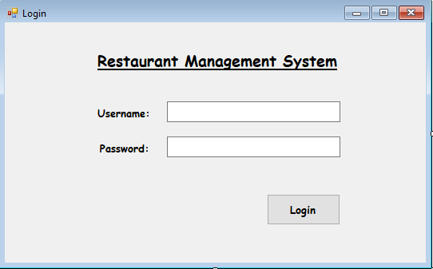 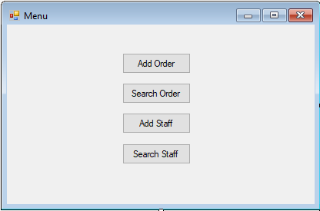

#### Figure 1: Login Window

Figure 2: Menu window

Figure 1: Login window

# 2 Handling Orders

|  |  |
| --- | --- |
|  | This sub-section explores the interface provided by the system to handle orders. All the functionality related to orders, whether it may be adding orders or viewing information related to the orders, is described. |

# 1.2.1 Add Orders

|  |  |
| --- | --- |
|  | The interface to add orders is shown in Figure 3. As visible, adding an order will require the id of the staff member taking and serving the order. After that, the food items and their quantity included in the order are put in. These items are then displayed in the following box to give an overview of the order. A separate box is dedicated to inputting the details of the customer placing the order. |

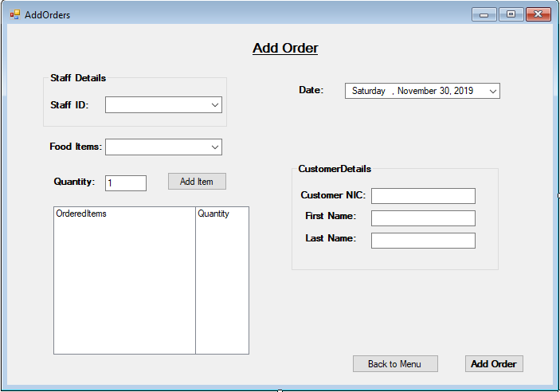

Figure 3: Add Order Window

# 1.2.2 Search Orders

|  |  |
| --- | --- |
| Figure 4: Search Order Window | This sub-section explores the interface provided by the system to handle orders. All the functionality related to orders, whether it may be adding orders or viewing information related to the orders, is described. |

# 1.3 Handling Staff

|  |  |
| --- | --- |
|  | This sub-section explores the interface provided by the system to handle orders. All the functionality related to orders, whether it may be adding orders or viewing information related to the orders, is described. |

# 1.2.1 Add Staff

|  |  |
| --- | --- |
|  | This sub-section explores the interface provided by the system to handle orders. All the functionality related to orders, whether it may be adding orders or viewing information related to the orders, is described. |

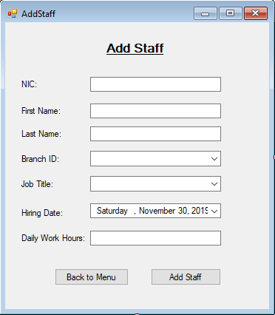

Figure 5: Add Staff Window

# 1.2.2 Search Staff

|  |  |
| --- | --- |
|  | This sub-section explores the interface provided by the system to handle orders. All the functionality related to orders, whether it may be adding orders or viewing information related to the orders, is described. |

